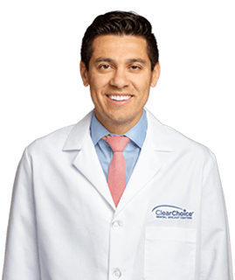

About Dr. Piñeyro
Dr. Piñeyro attended the University of New York at Albany and then received his Doctor of Dental Surgery degree and dental training from the Universidad Autonoma de Guadalajara in Guadalajara Jalisco, Mexico in 1999. Dr. Piñeyro completed an additional 2 years of Advanced Education in General Dentistry at the University of Rochester Eastman Dental Center, NY in 2003, He later completed a 3 year program in Prosthodontics and received his Graduate Prosthodontic Certificate in 2006.
In addition to being a key member of the team at ClearChoice Dental Implant Center in Federal Way, Dr. Piñeyro has been a prosthodontist in private practice since 2006. He has been a guest lecturer at the University of Rochester Eastman Dental Center, Loma Linda University, Oregon Health And Science University as well as a member of the Clinical Affiliate Faculty for Restorative Dentistry at the University of Washington School of Dentistry. Dr. Piñeyro has lectured both nationally and internationally to thousands of dentists on topics related to clinical prosthodontics and implant dentistry. He has been involved in dental research focusing on dental implants and has authored several publications in text books and peer reviewed dental journals such as the Journal of Prosthetic Dentistry, International Journal of Oral Maxillofacial Implants, Journal of Esthetic and Restorative Dentistry, and Dentistry Today. Dr. Piñeyro has established himself as an authority in the field of dental implants and has been a member of the American College of Prosthodontists, the American Dental Association, the American Prosthodontic Society, and the Washington State Society of Prosthodontists. In his spare time, Dr. Piñeyro enjoys playing soccer, and traveling with his wife and daughters. He is fluent in English, Spanish, and Italian.

Career Highlights
- DDS – Universidad Autonoma de Guadalajara
- Advanced Education in General Dentistry, University of Rochester Eastman Dental Center, NY
- Certificate in Prosthodontics – University of Rochester Eastman Dental Center
- Member of the American College of Prosthodontists
- Member of the American Dental Association
- Member of the American Prosthodontic Society
- Member of the Washington State Society of Prosthodontists

