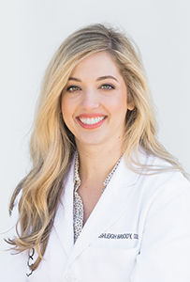

Ashleigh Briody, DDS

Dr. Ashleigh Briody received her DDS from Louisiana State University, and trained in oral and maxillofacial pathology at The Ohio State University College of Dentistry. She is a Fellow in the American Academy of Oral and Maxillofacial Pathology. In addition to clinical and microscopic diagnosis, Dr. Briody also offers biopsy services. Dr. Briody is a member of the team at Oral Pathology at Central Ohio Skin & Cancer.

